**Exploratory data Analysis (EDA)**

**Data Types:**

1. Year : Integer
2. make : String
3. model : String
4. trim : String
5. body : string
6. transmission : String
7. State : String
8. Condition : integer
9. Odometer : integer
10. Color : String
11. Interior : String
12. Seller : String
13. Mmr : integer
14. Sellingprice : integer
15. Month : string

**Summary Statistics:**

**Row:** 188675

**Column:** 16

**Data Visualization :-**

**Univariate Analysis:**

1. **Top most seller**

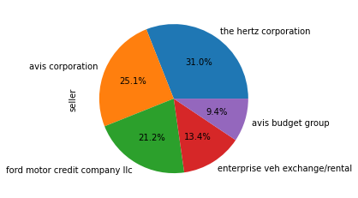

1. **Top most make**

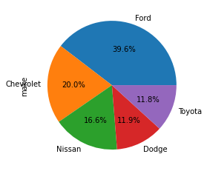

1. **Top body type**

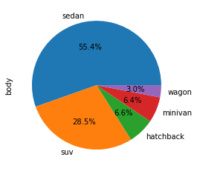

1. **Top trim**

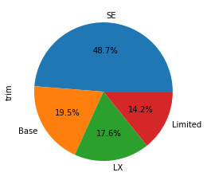

**Bivariate Analysis :**

1. **Top most seller on the basis of sale**

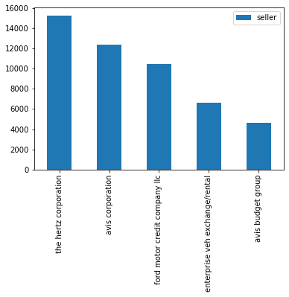

1. **Top most trim sale and its maker**

|  |  |  |
| --- | --- | --- |
| **trim** | **make** | **count** |
| **SE** | **Ford** | **13094** |
| **Base** | **Lexus** | **2204** |
| **LX** | **Kia** | **5457** |
| **Limited** | **Ford** | **2959** |



1. **Rare body type sale and its make and its ratings**

|  |  |  |
| --- | --- | --- |
| **Body type** | **maker** | **Rating(condition)** |
| **Ctd-v coupe** | **Cadillac** | **12.8** |
| **Tsx sport wagon** | **Acura** | **45.5** |
| **Granturismo convertible** | **maserati** | **49.0** |

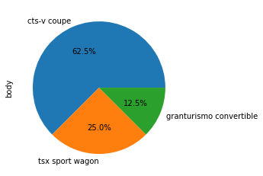

**4)rarer model sale and its make and its condition**

|  |  |  |
| --- | --- | --- |
| **model** | **make** | **condition** |
| **q3** | **Audi** | **5.0** |
| **range** | **Land rover** | **43.0** |
| **ghost** | **RollsRoyce** | **42.0** |
| **grand cherokee srt** | **jeep** | **47.0** |

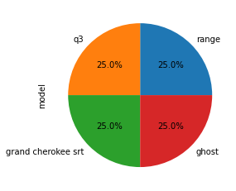

**Multivarient analysis:**

**Line plot of sale price by maker over month**